**GOPH 559 Lab 5 Report**

**Lab Section: B04**

GOPH 559

Lawrence Lines

Eneanwan Ekpo

Safian Qureshi

ID 10086638

**Abstract:**

The seismic data was collect in 1982 and 1984 from a survey aquired in the Arrowhead River area in the Northwest Territories, Canada. There were 7 seismic lines in the survey region. We drew a seismic section for 6 horizons in each of the seismic lines. The Kledo-Bovie Fault (a major fault) passed through the survey area in approximately a N-S direction. The Kledo-Bovie Fault is a reverse fault that is visible in seismic line 84-2. This fault most likely occurred in the Carboniferous era.

**Introduction:**

The survey area used to acquire the seismic data was aquired in the Arrowhead River area in the Northwest Territories, Canada. This area can be seen in Figure 1.0.

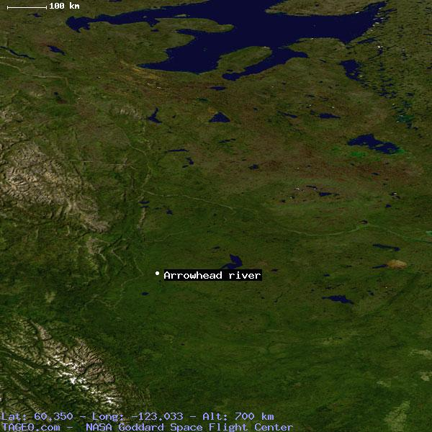

Figure 1.0: Arrowhead River area used to acquire seismic data.

A major fault can be seen if seismic line 84-2, this seismic line can be seen in Figure 1.1 and 1.2. This fault is the Kledo-Bovie fault, which is a reverse fault that passes through the area in approximately a N-S direction. There is less clarity in the data as you go down in depth. Horizons and faults were interpreted by double clicking the line of interest in the base map (Figure 1.2)

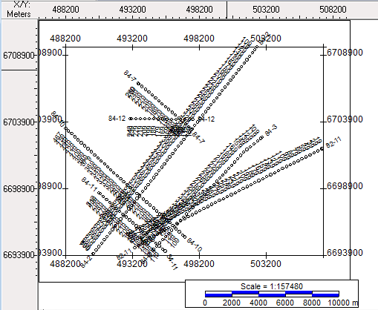

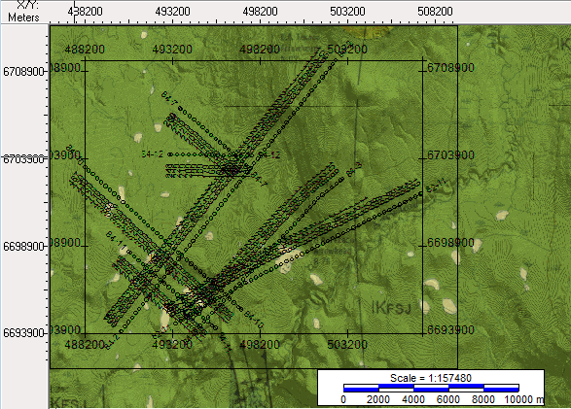Figure 1.1: Seismic location map.

Figure 1.2: Base map for region.

The time structure maps were drawn for horizon 1, 2 and 6. The 3 time structure maps show the travel times and also where the fault is located. Using this information, we were able to produce two isochron maps, which show the difference in travel times for horizon 1, 2 and 6.

**Data:**

We started drawing our horizons on line 84-2 at shot 120 using the travel time data was supplied in the lab for line84-2, SP 120. On line 84-2 (Figure 2.0) there is a visible reverse fault that approximately occurs between shots 400 and 340. This fault cuts through horizons 3, 4, 5 and 6. And does not cut through horizons 1 and 2. Therefore it is concluded that this faulting occurred before the deposition of horizons one and two.

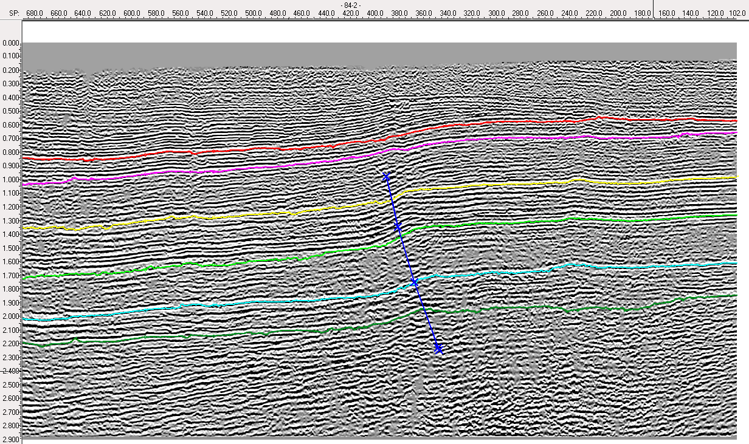

Figure 2.0: Seismic line 84-2.

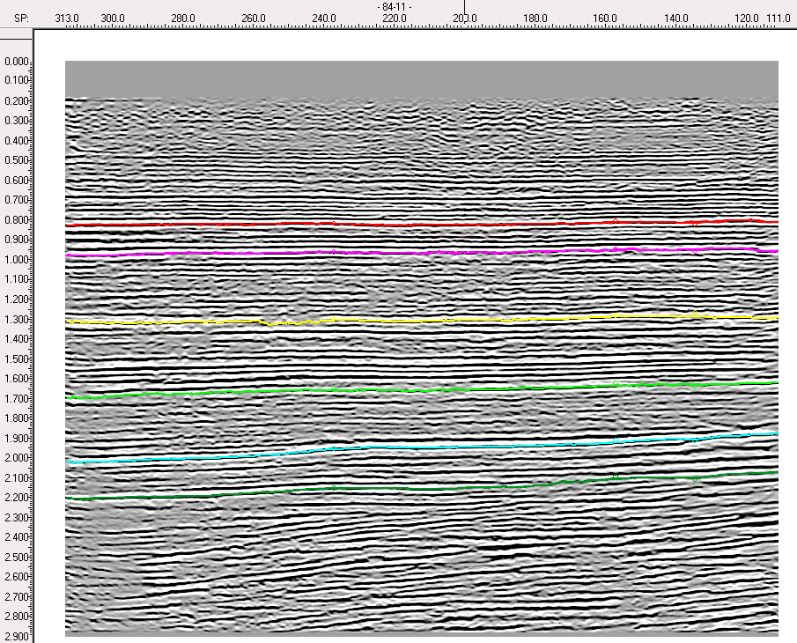

Figure 2.1: Seismic line 84-11.

Time structure maps were drawn for horizons 1, 2 and 6. These maps showed the depth of the region using the two-way travel times. For the time-structure map for horizon 1, it is visible that the NE corner (top-right) has a smaller depth and gradually increases towards the SW corner (bottom-left), which is seen in Figure 3.0. Similar trends are observed in time structure maps for horizons 2 and 6 (Figures 3.1 and 3.2) where the NE corner is at a smaller depth and the SW is at a larger depth. When this data is compared to Figure 2.0, it is concluded that the fault in the area is a reverse fault.

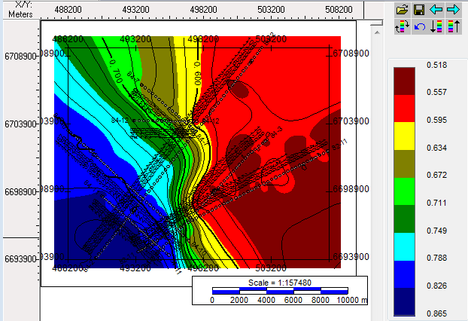

Figure 3.0: Time Structure map for Horizon 1.

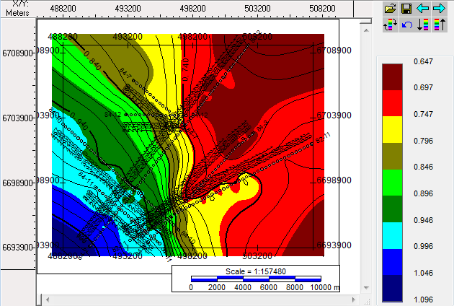

Figure 3.1: Time Structure map for Horizon 2.

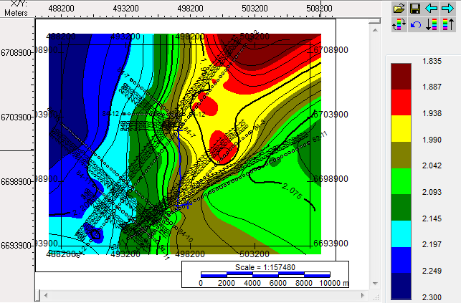

Figure 3.2: Time Structure map for Horizon 6.

Using these three time structure maps, we were able to create two isochron maps. The two isochron maps show the difference in travel times between horizon 1 and 2, and horizons 2 and 6. This shows the thickness of the layers for the seismic region. Figure 4.0 depicts the time period between the Cretaceous – Kotcho and Figure 4.1 depicts the Kotcho – Top of Proterozoic time period. In figure 4.0, one can see the thickest layers are the blue portions in the NE corner and a little in the middle of the map. The thinnest layer is the red section in the SW corner. For Figure 4.1 (Kotcho-Top of Proterozoic), the thinnest layers (red section) are visible in the NW and SE corners of the map, while the thickest are in the SW corner (blue section).

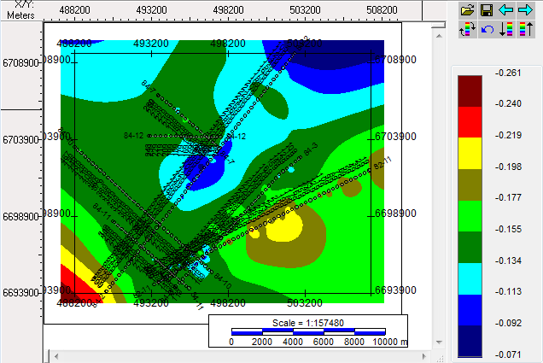

Figure 4.0: Isochron Map for the Cretaceous – Kotcho time interval

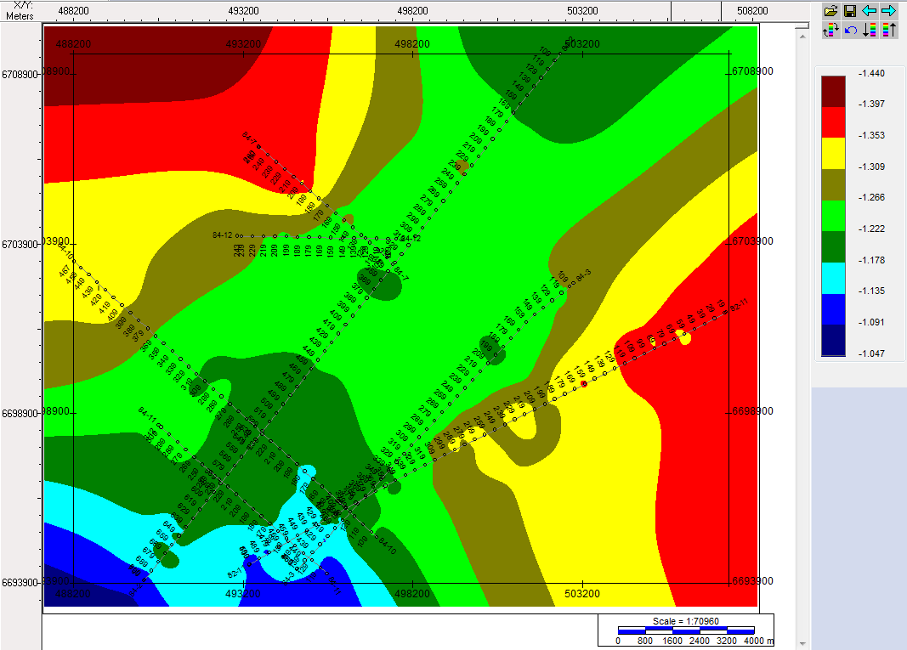

**Interpretation And Conclusion:**

Due to the law of original horizontality, we know that all layers were originally deposited horizontally. With the oldest units being deposited first, and therefore being at the bottom of the section. And the youngest units being deposited last, and therefore being at the top of the section. Since the Kledo-Bovie fault does not cut through horizons 1 and 2, we know that faulting occurred before the deposition of horizons 1 and 2. The fault does not offset the first two layers, although there is a slight uplift for horizons 1 and 2, a possible cause of this uplift is erosion. It is conclude that there was deposition of horizons 6,5,4 and 3 first, followed by the Kledo-Bovie faulting event, and then the deposition of horizons 2 and 1, and then a time period of erosion.

The Kingdom software interpretation package was used to interpret the seismic sections in the Arrowhead River area. From the obtained data, it was concluded that there is a reverse faulting event (Kledo-Bovie fault) that occurred before the deposition of horizons one and two.

**References:**

Dixon, J., 1997. Cretaceous stratigraphy in the subsurface of Great Slave Plain, Southern NWT. Bulletin of Canadian Petroleum Geology, Vol 45, No. 2 p. 178-193.

MacLean, B.C. and Morrow, D.C., 2004. Bovie Structure: its evolution and regional context. Bulletin of Canadian Petroleum Geology, Vol. 52, No. 4, p. 302-324.

Morrow, D.W., Jones, A.L., and Dixon, J. 2006. Infrastructure and resources of the Northern Canadian Mainland Sedimentary Basin. Geological Survey of Canada, Open File 5152, 1 CD-ROM.